Which of the following statements accurately describes the relationship of quiz questions and homework problems to exam questions? **The homework questions are much more indicative of the level of difficulty of exam questions than the quiz questions. Quiz questions are (mostly) auto-gradable so we can get quick feedback, whereas exam questions are made to test our actual understanding of the material.**

Which property of regular expressions could we use to show that (a*b + d)*(a*b + d) =

(a*b + d)? **closure 5.1**

Which property of regular expressions could we use to show that a(d + e) + (fg* + h)bc =

ad + ae + (fg* + h)bc? **distrib 3.1**

Which property of regular expressions could we use to show that (a*bc*)* = ^ + (a*bc*) +

(a*bc*)2(a*bc*)*? **closure 5.4**

Which of the following answers is a simplification of the regular expression aa(b* + a) +

a(ab* + aa) + a(b + b + b)? **a(aa + ab* + b)**

A student was asked to prove the following using the properties of regular expressions:

c((a + b)c)* + d* = ((ca + cb)*c + d*(^ + d*). They wrote the following proof (it’s correct, they just left out the “where R =” substitutions):

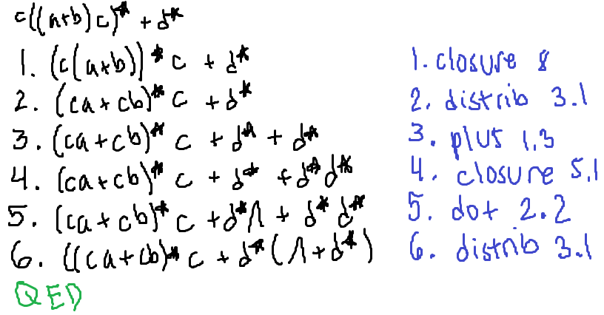

* On line 1, they should have written: **R = c** and **S = a + b**
* On line 2, they should have written: **R = c**, **S = a**, and **T = b**
* On line 3, they should have written: **R = d\***